S.SHIVA RANGA REDDY
192411178
INTERNET PROGRAMING-CSA4308

LAB PROGRAMS

11)PROGRAM
<!DOCTYPE html>
<html lang="en">
<head>
<meta charset="UTF-8">
<meta name="viewport" content="width=device-width, initial-scale=1.0">

<title>Home Finder - Real Estate Platform</title>

<style>
* {
margin: 0;
padding: 0;
box-sizing: border-box;
font-family: Arial, sans-serif;
}

body {
background: #f5f7fa;
color: #333;
}

/* Header */
header {
background: #12355b;
color: white;
padding: 18px 7%;
display: flex;
justify-content: space-between;
align-items: center;
position: sticky;
top: 0;
z-index: 1000;
}

.logo {
font-size: 28px;
font-weight: bold;
}

.logo span {
color: #ffb703;
}

nav a {
color: white;
text-decoration: none;
margin-left: 25px;
font-size: 16px;
}

nav a:hover {
color: #ffb703;
}

/* Hero */
.hero {
min-height: 430px;
background: linear-gradient(
rgba(18, 53, 91, 0.8),
rgba(18, 53, 91, 0.8)
),
url("https://images.unsplash.com/photo-1560518883-ce09059eeffa")
center/cover;

display: flex;
align-items: center;
justify-content: center;
text-align: center;
color: white;
padding: 40px 20px;
}

.hero-content h1 {
font-size: 48px;
margin-bottom: 15px;
}

.hero-content p {
font-size: 20px;
margin-bottom: 30px;
}

/* Search Box */
.search-box {
background: white;
padding: 20px;
border-radius: 12px;
display: flex;
flex-wrap: wrap;
gap: 10px;
max-width: 1000px;
margin: auto;
box-shadow: 0 5px 20px rgba(0,0,0,0.3);
}

.search-box input,
.search-box select {
padding: 14px;
border: 1px solid #ddd;
border-radius: 6px;
flex: 1;
min-width: 150px;
}

button {
background: #ffb703;
color: #222;
border: none;
padding: 14px 25px;
border-radius: 6px;
cursor: pointer;
font-weight: bold;
}

button:hover {
background: #fb8500;
color: white;
}

/* Sections */
section {
padding: 60px 7%;
}

.section-title {
text-align: center;
margin-bottom: 35px;
}

.section-title h2 {
color: #12355b;
font-size: 32px;
}

.section-title p {
margin-top: 10px;
color: #666;
}

/* Properties */
.property-grid {
display: grid;
grid-template-columns: repeat(auto-fit, minmax(280px, 1fr));
gap: 25px;
}

.property-card {
background: white;
border-radius: 12px;
overflow: hidden;
box-shadow: 0 4px 15px rgba(0,0,0,0.1);
transition: 0.3s;
}

.property-card:hover {
transform: translateY(-5px);
}

.property-card img {
width: 100%;
height: 210px;
object-fit: cover;
}

.property-info {
padding: 20px;
}

.property-info h3 {
color: #12355b;
margin-bottom: 10px;
}

.price {
color: #e63946;
font-size: 20px;
font-weight: bold;
margin: 10px 0;
}

.property-info p {
margin: 7px 0;
color: #666;
}

.card-buttons {
display: flex;
gap: 10px;
margin-top: 15px;
}

.card-buttons button {
flex: 1;
}

.favorite {
background: #12355b;
color: white;
}

/* Features */
.features {
background: white;
}

.feature-grid {
display: grid;
grid-template-columns: repeat(auto-fit, minmax(220px, 1fr));
gap: 25px;
}

.feature-card {
padding: 30px;
text-align: center;
border-radius: 10px;
background: #f5f7fa;
border: 1px solid #eee;
}

.feature-card .icon {
font-size: 40px;
margin-bottom: 15px;
}

.feature-card h3 {
color: #12355b;
margin-bottom: 10px;
}

/* Login */
.login-section {
background: #12355b;
color: white;
}

.login-box {
max-width: 450px;
margin: auto;
background: white;
color: #333;
padding: 30px;
border-radius: 12px;
}

.login-box h2 {
text-align: center;
color: #12355b;
margin-bottom: 20px;
}

.login-box input {
width: 100%;
padding: 14px;
margin: 8px 0;
border: 1px solid #ddd;
border-radius: 6px;
}

.login-box button {
width: 100%;
margin-top: 15px;
}

/* Agents */
.agent-grid {
display: grid;
grid-template-columns: repeat(auto-fit, minmax(250px, 1fr));
gap: 25px;
}

.agent-card {
background: white;
padding: 25px;
text-align: center;
border-radius: 10px;
box-shadow: 0 3px 15px rgba(0,0,0,0.1);
}

.agent-card img {
width: 100px;
height: 100px;
border-radius: 50%;
object-fit: cover;
}

.agent-card h3 {
margin: 15px 0 5px;
color: #12355b;
}

/* Map */
.map-section {
background: white;
}

.map {
width: 100%;
height: 400px;
border: 0;
border-radius: 10px;
}

/* Advertisement */
.advertisement {
background: #ffb703;
padding: 30px;
text-align: center;
border-radius: 10px;
}

.advertisement h2 {
margin-bottom: 10px;
}

/* Customer Records */
.records {
background: white;
}

table {
width: 100%;
border-collapse: collapse;
background: white;
}

th, td {
padding: 15px;
border: 1px solid #ddd;
text-align: left;
}

th {
background: #12355b;
color: white;
}

/* Footer */
footer {
background: #0b2239;
color: white;
text-align: center;
padding: 30px;
}

footer p {
margin: 8px;
}

/* Responsive */
@media (max-width: 768px) {

header {
flex-direction: column;
gap: 15px;
}

nav a {
margin: 5px;
font-size: 14px;
}

.hero-content h1 {
font-size: 35px;
}

.search-box {
flex-direction: column;
}

.search-box input,
.search-box select,
.search-box button {
width: 100%;
}

table {
font-size: 12px;
}
}
</style>
</head>

<body>

<!-- HEADER -->
<header>

<div class="logo">
Home<span>Finder</span>
</div>

<nav>
<a href="#home">Home</a>
<a href="#properties">Properties</a>
<a href="#agents">Agents</a>
<a href="#login">Login</a>
<a href="#contact">Contact</a>
</nav>

</header>

<!-- HERO -->
<section class="hero" id="home">

<div class="hero-content">

<h1>Find Your Dream Home</h1>

<p>
Search and discover houses, lands and commercial properties
within your budget.
</p>

<!-- SEARCH -->
<div class="search-box">

<input
type="text"
id="location"
placeholder="Enter location"
>

<input
type="number"
id="maxPrice"
placeholder="Maximum Price"
>

<select id="propertyType">

<option value="">Property Type</option>

<option value="House">
House
</option>

<option value="Land">
Land
</option>

<option value="Apartment">
Apartment
</option>

<option value="Commercial">
Commercial
</option>

</select>

<select id="amenity">

<option value="">Amenities</option>

<option value="Parking">
Parking
</option>

<option value="Swimming Pool">
Swimming Pool
</option>

<option value="Garden">
Garden
</option>

</select>

<button onclick="searchProperties()">
Search
</button>

<button onclick="saveSearch()">
Save Search
</button>

</div>

</div>

</section>

<!-- FEATURES -->
<section class="features">

<div class="section-title">

<h2>Why Choose Home Finder?</h2>

<p>
Everything you need to find the perfect property.
</p>

</div>

<div class="feature-grid">

<div class="feature-card">

<div class="icon">🏠</div>

<h3>Property Search</h3>

<p>
Search residential, commercial and land properties.
</p>

</div>

<div class="feature-card">

<div class="icon">🔍</div>

<h3>Advanced Filters</h3>

<p>
Filter properties by location, price and amenities.
</p>

</div>

<div class="feature-card">

<div class="icon">❤️</div>

<h3>Save Favorites</h3>

<p>
Save your favorite properties for future reference.
</p>

</div>

<div class="feature-card">

<div class="icon">🗺️</div>

<h3>Interactive Map</h3>

<p>
Locate properties and explore nearby areas.
</p>

</div>

</div>

</section>

<!-- PROPERTIES -->
<section id="properties">

<div class="section-title">

<h2>Featured Properties</h2>

<p>
Explore some of our latest property listings.
</p>

</div>

<div class="property-grid" id="propertyGrid">

<!-- PROPERTY 1 -->

<div class="property-card"
data-location="Hyderabad"
data-price="7500000"
data-type="House">

<img
src="https://images.unsplash.com/photo-1600585154340-be6161a56a0c"
alt="Modern House"
>

<div class="property-info">

<h3>Modern Family House</h3>

<p>📍 Hyderabad, Telangana</p>

<p>🛏 3 Bedrooms | 🛁 2 Bathrooms</p>

<p>📐 2,000 Sq. Ft.</p>

<div class="price">
₹75,00,000
</div>

<div class="card-buttons">

<button onclick="viewProperty('Modern Family House')">
View Details
</button>

<button
class="favorite"
onclick="addFavorite('Modern Family House')">
❤️
</button>

</div>

</div>

</div>

<!-- PROPERTY 2 -->

<div class="property-card"
data-location="Bangalore"
data-price="4500000"
data-type="Apartment">

<img
src="https://images.unsplash.com/photo-1545324418-cc1a3fa10c00"
alt="Apartment"
>

<div class="property-info">

<h3>Luxury Apartment</h3>

<p>📍 Bangalore, Karnataka</p>

<p>🛏 2 Bedrooms | 🛁 2 Bathrooms</p>

<p>📐 1,200 Sq. Ft.</p>

<div class="price">
₹45,00,000
</div>

<div class="card-buttons">

<button onclick="viewProperty('Luxury Apartment')">
View Details
</button>

<button
class="favorite"
onclick="addFavorite('Luxury Apartment')">
❤️
</button>

</div>

</div>

</div>

<!-- PROPERTY 3 -->

<div class="property-card"
data-location="Vijayawada"
data-price="2500000"
data-type="Land">

<img
src="https://images.unsplash.com/photo-1500382017468-9049fed747ef"
alt="Land Property"
>

<div class="property-info">

<h3>Residential Land</h3>

<p>📍 Vijayawada, Andhra Pradesh</p>

<p>📐 2,400 Sq. Ft.</p>

<div class="price">
₹25,00,000
</div>

<div class="card-buttons">

<button onclick="viewProperty('Residential Land')">
View Details
</button>

<button
class="favorite"
onclick="addFavorite('Residential Land')">
❤️
</button>

</div>

</div>

</div>

</div>

</section>

<!-- MAP -->
<section class="map-section">

<div class="section-title">

<h2>Find Properties on Map</h2>

<p>
Explore property locations and nearby areas.
</p>

</div>

<iframe
class="map"
src="https://www.google.com/maps?q=Hyderabad,India&output=embed">
</iframe>

</section>

<!-- AGENTS -->
<section id="agents">

<div class="section-title">

<h2>Real Estate Agents</h2>

<p>
Contact trusted agents and property companies.
</p>

</div>

<div class="agent-grid">

<div class="agent-card">

<img
src="https://randomuser.me/api/portraits/men/32.jpg"
alt="Agent"
>

<h3>Rahul Kumar</h3>

<p>Hyderabad Properties</p>

<p>📞 +91 98765 43210</p>

<br>

<button onclick="contactAgent('Rahul Kumar')">
Contact Agent
</button>

</div>

<div class="agent-card">

<img
src="https://randomuser.me/api/portraits/women/44.jpg"
alt="Agent"
>

<h3>Priya Sharma</h3>

<p>South India Realty</p>

<p>📞 +91 98765 12345</p>

<br>

<button onclick="contactAgent('Priya Sharma')">
Contact Agent
</button>

</div>

<div class="agent-card">

<img
src="https://randomuser.me/api/portraits/men/45.jpg"
alt="Agent"
>

<h3>Arjun Reddy</h3>

<p>Premium Land Developers</p>

<p>📞 +91 99887 66554</p>

<br>

<button onclick="contactAgent('Arjun Reddy')">
Contact Agent
</button>

</div>

</div>

</section>

<!-- ADVERTISEMENT -->
<section>

<div class="advertisement">

<h2>🏢 Advertise Your Property With Us</h2>

<p>
Reach thousands of buyers and renters looking for their dream property.
</p>

<br>

<button onclick="advertise()">
Add Your Advertisement
</button>

</div>

</section>

<!-- LOGIN -->
<section class="login-section" id="login">

<div class="login-box">

<h2>Buyer Login</h2>

<form onsubmit="login(event)">

<input
type="text"
id="username"
placeholder="Username"
required
>

<input
type="password"
id="password"
placeholder="Password"
required
>

<button type="submit">
Login
</button>

</form>

<p id="loginMessage"
style="text-align:center;margin-top:15px;">
</p>

</div>

</section>

<!-- CUSTOMER RECORDS -->
<section class="records">

<div class="section-title">

<h2>Customer Visit Records</h2>

<p>
Maintain records of customers visiting the website.
</p>

</div>

<table>

<thead>

<tr>

<th>Customer</th>

<th>Property</th>

<th>Date</th>

<th>Status</th>

</tr>

</thead>

<tbody id="customerTable">

<tr>

<td>Demo Customer</td>

<td>Modern Family House</td>

<td>31 July 2026</td>

<td>Viewed</td>

</tr>

</tbody>

</table>

</section>

<!-- FOOTER -->
<footer id="contact">

<h2>Home Finder</h2>

<p>
Your trusted platform for finding homes, lands and commercial properties.
</p>

<p>
Email: support@homefinder.com
</p>

<p>
Phone: +91 98765 43210
</p>

<p>
© 2026 Home Finder. All Rights Reserved.
</p>

</footer>

<!-- JAVASCRIPT -->
<script>

// Search Properties
function searchProperties() {

let location =
document.getElementById("location").value.toLowerCase();

let maxPrice =
document.getElementById("maxPrice").value;

let type =
document.getElementById("propertyType").value;

let cards =
document.querySelectorAll(".property-card");

let found = false;

cards.forEach(function(card) {

let cardLocation =
card.dataset.location.toLowerCase();

let cardPrice =
Number(card.dataset.price);

let cardType =
card.dataset.type;

let locationMatch =
location === "" ||
cardLocation.includes(location);

let priceMatch =
maxPrice === "" ||
cardPrice <= Number(maxPrice);

let typeMatch =
type === "" ||
cardType === type;

if (locationMatch && priceMatch && typeMatch) {

card.style.display = "block";

found = true;

} else {

card.style.display = "none";

}

});

if (!found) {

alert(
"No properties found matching your search criteria."
);

}

}

// Save Search Criteria
function saveSearch() {

let searchData = {

location:
document.getElementById("location").value,

maxPrice:
document.getElementById("maxPrice").value,

propertyType:
document.getElementById("propertyType").value,

amenity:
document.getElementById("amenity").value

};

localStorage.setItem(
"savedSearch",
JSON.stringify(searchData)
);

alert(
"Your search criteria have been saved successfully!"
);

}

// Login
function login(event) {

event.preventDefault();

let username =
document.getElementById("username").value;

let password =
document.getElementById("password").value;

localStorage.setItem(
"username",
username
);

localStorage.setItem(
"password",
password
);

document.getElementById(
"loginMessage"
).innerHTML =
"Login successful! Welcome, " +
username + ".";

}

// Add Favorite
function addFavorite(property) {

let favorites =
JSON.parse(
localStorage.getItem("favorites")
) || [];

if (!favorites.includes(property)) {

favorites.push(property);

localStorage.setItem(
"favorites",
JSON.stringify(favorites)
);

alert(
property +
" added to your favorites!"
);

} else {

alert(
property +
" is already in your favorites."
);

}

}

// View Property
function viewProperty(property) {

alert(
"You selected: " +
property +
"\n\nProperty details will be displayed here."
);

}

// Contact Agent
function contactAgent(agent) {

alert(
"You are contacting " +
agent +
".\n\nThe agent will contact you shortly."
);

}

// Advertisement
function advertise() {

alert(
"Advertisement request submitted successfully!"
);

}

// Record customer visit
window.onload = function() {

let username =
localStorage.getItem("username");

if (username) {

let table =
document.getElementById(
"customerTable"
);

let row =
table.insertRow();

row.insertCell(0).innerHTML =
username;

row.insertCell(1).innerHTML =
"Home Finder Website";

row.insertCell(2).innerHTML =
new Date().toLocaleDateString();

row.insertCell(3).innerHTML =
"Visited";

}

};

</script>

</body>
</html>
OUTPUT:
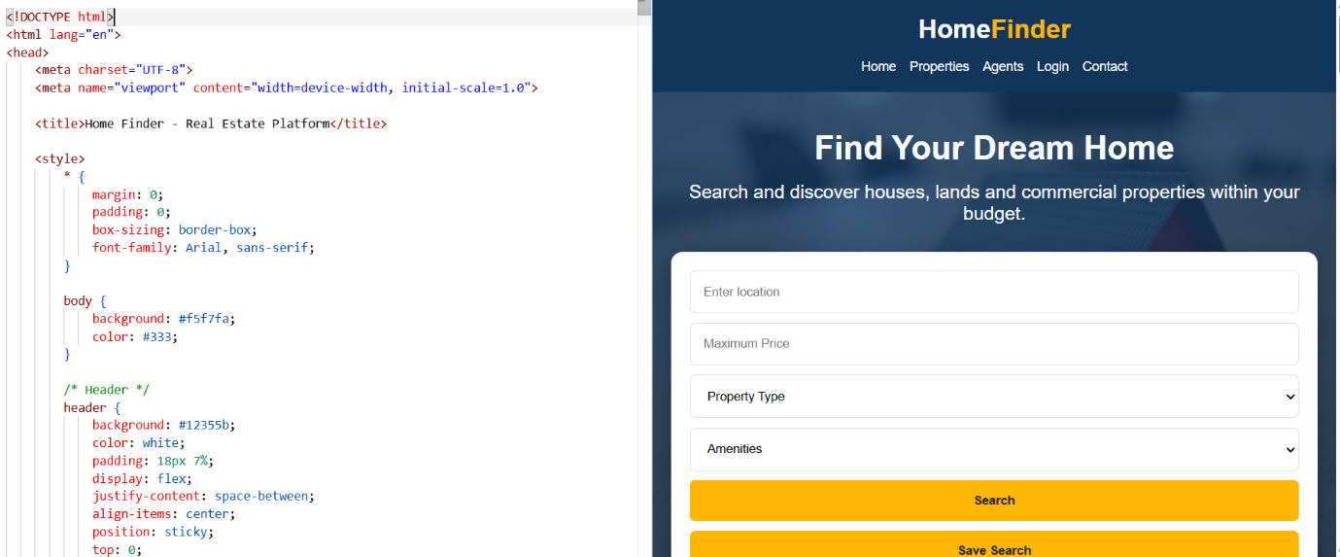

12)PROGRAM
<!DOCTYPE html>
<html>
<head>
<title>InsureEasy</title>

<style>
body {
font-family: Arial;
margin: 0;
background: #f2f6f8;
}

header {
background: #073b4c;
color: white;
padding: 20px;
text-align: center;
}

nav {
background: #06a77d;
padding: 12px;
text-align: center;
}

nav a {
color: white;
margin: 15px;
text-decoration: none;
}

section {
padding: 30px;
text-align: center;
}

.box {
background: white;
padding: 20px;
margin: 15px auto;
max-width: 500px;
border-radius: 10px;
}

input, select, button {
padding: 10px;
margin: 7px;
}

button {
background: #06a77d;
color: white;
border: none;
cursor: pointer;
}

footer {
background: #073b4c;
color: white;
padding: 20px;
text-align: center;
}
</style>
</head>

<body>

<header>
<h1>InsureEasy</h1>
<p>Online Insurance Management System</p>
</header>

<nav>
<a href="#home">Home</a>
<a href="#policies">Policies</a>
<a href="#login">Login</a>
<a href="#admin">Admin</a>
<a href="#agent">Agent</a>
<a href="#user">User</a>
</nav>

<section id="home">
<h2>Welcome to InsureEasy</h2>
<p>Compare, purchase and manage your insurance policies easily.</p>

<button onclick="alert('Welcome to InsureEasy!')">
Get Started
</button>
</section>

<section id="policies">
<h2>Insurance Policies</h2>

<div class="box">
<h3>Health Insurance</h3>
<p>Premium: ₹12,000 / Year</p>
<button>Apply Now</button>
</div>

<div class="box">
<h3>Auto Insurance</h3>
<p>Premium: ₹8,000 / Year</p>
<button>Apply Now</button>
</div>

<div class="box">
<h3>Home Insurance</h3>
<p>Premium: ₹15,000 / Year</p>
<button>Apply Now</button>
</div>
</section>

<section id="login">
<h2>User Login</h2>

<div class="box">
<input type="text" placeholder="Username">
<input type="password" placeholder="Password">
<button onclick="login()">Login</button>
</div>
</section>

<section id="admin">
<h2>Admin</h2>

<div class="box">
<p>✔ Approve Agent Login</p>
<p>✔ View Agent Details</p>
<button onclick="alert('Agent Approved')">
Approve Agent
</button>
</div>
</section>

<section id="agent">
<h2>Agent</h2>

<div class="box">
<p>✔ Register</p>
<p>✔ Create Customer</p>
<p>✔ Manage Customer Details</p>
<p>✔ Manage Policy Details</p>

<button onclick="alert('Customer Created')">
Create Customer
</button>
</div>
</section>

<section id="user">
<h2>User Dashboard</h2>

<div class="box">
<p>✔ Manage Policy Details</p>
<p>✔ View Premium</p>
<p>✔ Receive SMS Alerts</p>

<button onclick="alert('SMS Alert Sent')">
Send SMS Alert
</button>
</div>
</section>

<footer>
<p>© 2026 InsureEasy | Online Insurance Management System</p>
</footer>

<script>
function login() {
alert("Login Successful!");
}
</script>

</body>
</html>
OUTPUT:
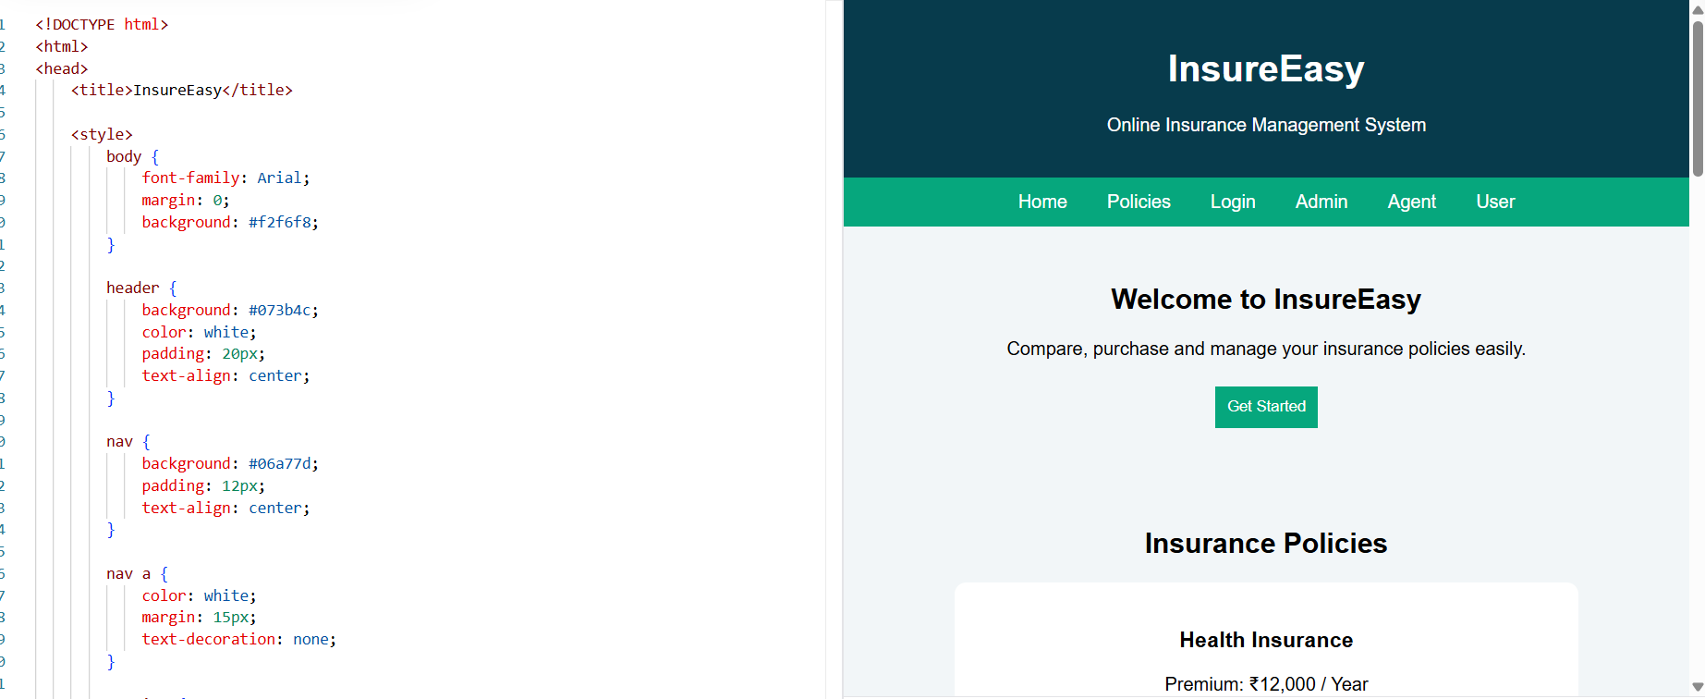

13)PROGRAM
<!DOCTYPE html>
<html>
<head>
<title>BlossomGifts</title>

<style>
body {
font-family: Arial;
margin: 0;
background: #fff5f7;
}

header {
background: #d6336c;
color: white;
text-align: center;
padding: 20px;
}

nav {
background: #ff8fab;
padding: 12px;
text-align: center;
}

nav a {
color: white;
margin: 15px;
text-decoration: none;
}

section {
padding: 25px;
text-align: center;
}

.box {
background: white;
display: inline-block;
width: 220px;
padding: 20px;
margin: 10px;
border-radius: 10px;
box-shadow: 0 2px 8px #ccc;
}

button {
background: #d6336c;
color: white;
border: none;
padding: 10px 20px;
cursor: pointer;
}

footer {
background: #d6336c;
color: white;
text-align: center;
padding: 20px;
}
</style>
</head>

<body>

<header>
<h1>🌸 BlossomGifts</h1>
<p>Flowers and Gifts for Every Occasion</p>
</header>

<nav>
<a href="#home">Home</a>
<a href="#categories">Categories</a>
<a href="#products">Products</a>
<a href="#cart">Cart</a>
<a href="#login">Login</a>
</nav>

<section id="home">
<h2>Welcome to BlossomGifts</h2>
<p>Send beautiful flowers and thoughtful gifts to your loved ones.</p>
<button onclick="alert('Welcome to BlossomGifts!')">
Shop Now
</button>
</section>

<section id="categories">
<h2>Categories</h2>

<div class="box">
<h3>🌹 Flowers</h3>
<p>Roses, Lilies, Bouquets</p>
</div>

<div class="box">
<h3>🎁 Gifts</h3>
<p>Gift Baskets and Personalized Gifts</p>
</div>

<div class="box">
<h3>🎂 Occasions</h3>
<p>Birthday, Anniversary, Wedding</p>
</div>
</section>

<section id="products">
<h2>Popular Products</h2>

<div class="box">
<h3>Rose Bouquet</h3>
<p>Price: ₹999</p>
<button onclick="addCart('Rose Bouquet')">
Add to Cart
</button>
</div>

<div class="box">
<h3>Gift Basket</h3>
<p>Price: ₹1499</p>
<button onclick="addCart('Gift Basket')">
Add to Cart
</button>
</div>

<div class="box">
<h3>Birthday Gift</h3>
<p>Price: ₹799</p>
<button onclick="addCart('Birthday Gift')">
Add to Cart
</button>
</div>
</section>

<section id="cart">
<h2>Shopping Cart</h2>
<p id="cartItems">Your cart is empty.</p>

<button onclick="checkout()">
Checkout
</button>
</section>

<section id="login">
<h2>Customer Login</h2>

<input type="text" placeholder="Username">
<input type="password" placeholder="Password">

<button onclick="login()">
Login
</button>
</section>

<section>
<h2>Admin Panel</h2>

<p>✔ Add Items</p>
<p>✔ Remove Items</p>
<p>✔ Modify Item Prices</p>
<p>✔ Manage Inventory</p>
<p>✔ View Customer Information</p>
<p>✔ View Order Summary</p>

<button onclick="alert('Admin Panel Opened')">
Manage Website
</button>
</section>

<footer>
<p>© 2026 BlossomGifts</p>
<p>Flowers and Gifts Delivered With Love 💐</p>
</footer>

<script>

let cart = [];

function addCart(item) {
cart.push(item);

document.getElementById("cartItems").innerHTML =
cart.join("<br>");

alert(item + " added to cart!");
}

function checkout() {
alert("Order placed successfully!");
}

function login() {
alert("Login Successful!");
}

</script>

</body>
</html>
OUTPUT:
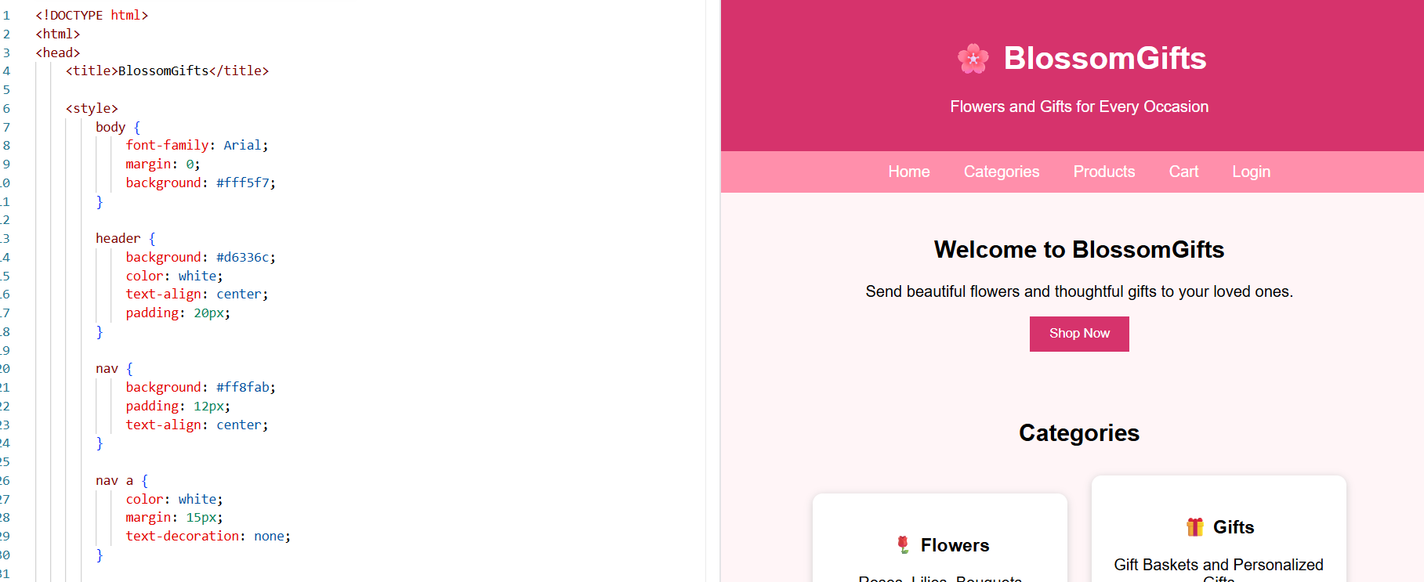

14)PROGRAM
<!DOCTYPE html>
<html>
<head>
<title>ReNewMarket</title>

<style>
body {
font-family: Arial;
margin: 0;
background: #f2f7f2;
}

header {
background: #2e7d32;
color: white;
text-align: center;
padding: 20px;
}

nav {
background: #66bb6a;
padding: 12px;
text-align: center;
}

nav a {
color: white;
margin: 15px;
text-decoration: none;
}

section {
padding: 25px;
text-align: center;
}

.box {
background: white;
display: inline-block;
width: 220px;
padding: 20px;
margin: 10px;
border-radius: 10px;
box-shadow: 0 2px 8px #ccc;
}

button {
background: #2e7d32;
color: white;
border: none;
padding: 10px 20px;
margin: 5px;
cursor: pointer;
}

footer {
background: #2e7d32;
color: white;
text-align: center;
padding: 20px;
}
</style>
</head>

<body>

<header>
<h1>♻️ ReNewMarket</h1>
<p>Buy and Sell Pre-Owned Products</p>
</header>

<nav>
<a href="#home">Home</a>
<a href="#categories">Categories</a>
<a href="#products">Products</a>
<a href="#login">Login</a>
<a href="#admin">Admin</a>
</nav>

<section id="home">
<h2>Welcome to ReNewMarket</h2>
<p>Buy and sell quality second-hand goods easily.</p>

<input type="text" placeholder="Search products">
<button onclick="search()">Search</button>
</section>

<section id="categories">
<h2>Categories</h2>

<div class="box">
<h3>📱 Electronics</h3>
<p>Mobiles, Laptops and TVs</p>
</div>

<div class="box">
<h3>🪑 Furniture</h3>
<p>Tables, Chairs and Sofas</p>
</div>

<div class="box">
<h3>👕 Clothing</h3>
<p>New and Used Clothes</p>
</div>
</section>

<section id="products">
<h2>Available Products</h2>

<div class="box">
<h3>Used Laptop</h3>
<p>Price: ₹25,000</p>
<button onclick="buy('Used Laptop')">
Buy Now
</button>
</div>

<div class="box">
<h3>Second-Hand Sofa</h3>
<p>Price: ₹8,000</p>
<button onclick="buy('Second-Hand Sofa')">
Buy Now
</button>
</div>

<div class="box">
<h3>Used Mobile</h3>
<p>Price: ₹12,000</p>
<button onclick="buy('Used Mobile')">
Buy Now
</button>
</div>
</section>

<section id="login">
<h2>User Login</h2>

<input type="text" placeholder="Username">
<input type="password" placeholder="Password">

<button onclick="login()">Login</button>
</section>

<section id="admin">
<h2>Admin Management</h2>

<div class="box">
<h3>User Management</h3>
<p>✔ Add User</p>
<p>✔ Edit User</p>
<p>✔ Delete User</p>
</div>

<div class="box">
<h3>Category Management</h3>
<p>✔ Add Category</p>
<p>✔ Delete Category</p>
</div>

<div class="box">
<h3>Commodity Management</h3>
<p>✔ Edit Commodity</p>
<p>✔ Delete Commodity</p>
</div>

<div class="box">
<h3>Order Management</h3>
<p>✔ Shipped / Received</p>
<p>✔ Delete Order</p>
</div>
</section>

<footer>
<p>© 2026 ReNewMarket</p>
<p>♻️ Buy Used. Sell Smart. Save the Planet.</p>
</footer>

<script>

function login() {
alert("Login Successful!");
}

function search() {
alert("Searching for products...");
}

function buy(item) {
alert(item + " order placed successfully!");
}

</script>

</body>
</html>
OUTPUT:
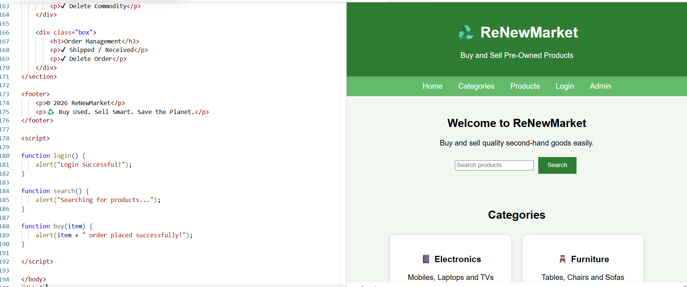

15)PROGRAM
<!DOCTYPE html>
<html>
<head>
<title>EasyToll</title>

<style>
body {
font-family: Arial;
margin: 0;
background: #f2f5f7;
}

header {
background: #1565c0;
color: white;
text-align: center;
padding: 20px;
}

nav {
background: #42a5f5;
padding: 12px;
text-align: center;
}

nav a {
color: white;
margin: 15px;
text-decoration: none;
}

section {
padding: 25px;
text-align: center;
}

.box {
background: white;
display: inline-block;
width: 220px;
padding: 20px;
margin: 10px;
border-radius: 10px;
box-shadow: 0 2px 8px #ccc;
}

input, button {
padding: 10px;
margin: 5px;
}

button {
background: #1565c0;
color: white;
border: none;
cursor: pointer;
}

footer {
background: #1565c0;
color: white;
text-align: center;
padding: 20px;
}
</style>
</head>

<body>

<header>
<h1>🚗 EasyToll</h1>
<p>Easy Online Toll Payment System</p>
</header>

<nav>
<a href="#home">Home</a>
<a href="#user">User</a>
<a href="#admin">Admin</a>
<a href="#toll">Toll Gate</a>
<a href="#login">Login</a>
</nav>

<section id="home">
<h2>Welcome to EasyToll</h2>
<p>Pay your toll in advance and travel without waiting.</p>

<button onclick="alert('Welcome to EasyToll!')">
Get Started
</button>
</section>

<section id="login">
<h2>User Login</h2>

<div class="box">
<input type="text" placeholder="Username">
<input type="password" placeholder="Password">

<button onclick="login()">
Login
</button>

<button onclick="register()">
Register
</button>
</div>
</section>

<section id="user">
<h2>User Services</h2>

<div class="box">
<h3>💰 e-Wallet</h3>
<button onclick="addMoney()">
Add Money
</button>
</div>

<div class="box">
<h3>🎫 Toll Ticket</h3>
<button onclick="buyTicket()">
Buy Toll Ticket
</button>
</div>

<div class="box">
<h3>📄 Toll Pass</h3>
<button onclick="applyPass()">
Apply Toll Pass
</button>
</div>

<div class="box">
<h3>🔄 Renewal</h3>
<button onclick="renewPass()">
Renew Toll Pass
</button>
</div>

<div class="box">
<h3>📱 QR Code</h3>
<button onclick="getQR()">
Get QR Code
</button>
</div>
</section>

<section id="admin">
<h2>Admin Panel</h2>

<div class="box">
<h3>Admin Management</h3>

<p>✔ Manage User & Toll Pass</p>
<p>✔ Manage Toll Login</p>
<p>✔ Approve Toll Pass</p>
<p>✔ Generate QR Code</p>
<p>✔ Create Toll Details</p>

<button onclick="alert('Admin Panel Opened')">
Manage
</button>
</div>
</section>

<section id="toll">
<h2>Toll Gate User</h2>

<div class="box">
<h3>Scan QR</h3>

<input type="text"
placeholder="Enter Toll Pass ID">

<button onclick="verifyPass()">
Verify Toll Pass
</button>

<p>✔ Verify Toll Pass ID</p>
<p>✔ Verify Toll Ticket</p>
<p>✔ Update Toll Location</p>
</div>
</section>

<footer>
<p>© 2026 EasyToll</p>
<p>🚗 Fast, Secure and Easy Toll Payments</p>
</footer>

<script>

function login() {
alert("Login Successful!");
}

function register() {
alert("Registration Successful!");
}

function addMoney() {
alert("Money added to e-Wallet!");
}

function buyTicket() {
alert("Toll Ticket Purchased!");
}

function applyPass() {
alert("Toll Pass Application Submitted!");
}

function renewPass() {
alert("Toll Pass Renewed!");
}

function getQR() {
alert("QR Code Generated!");
}

function verifyPass() {
alert("Toll Pass Verified Successfully!");
}

</script>

</body>
</html>
OUTPUT:
